**ADVISORY BOARD ON VETERANS AFFAIRS**

**FOR**

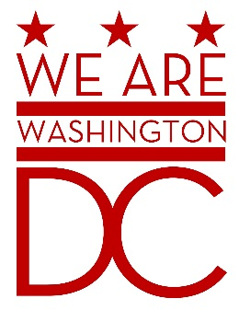

**MEETING AGENDA**

**Tuesday, June 2nd 2015**

**441 4th Street NW**

**One Judiciary Square Suite 540 South**

**Washington DC 20001**

**6:30 – 8:00 p.m.**

1. **Call to Order (**Chairman**)**
2. **Pledge of Allegiance (**Chairman**)**
3. **Members of the Public (2 minutes each to address the Board)**
4. **CLOSED SESSION OF THE MEETING WILL BEGIN**
5. **Advisory Board Members Roll Call** **(**Brenda Hall Recording Secretary**)**

1. **Discussion of Old Business (**Chairman**)**

Overview/Acceptance of June 2nd Minutes

1. **Discussion of New Business (**Chairman**)**

Status of Registration for training

Formulation of Committees

Participation of Community Events (on behalf of the Mayor/MOVA)

1. **Future Events**
2. **Adjournment (**Chairman**)**