**ADVISORY BOARD ON VETERANS AFFAIRS**

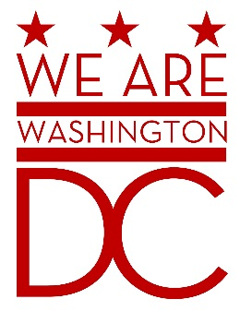

**MEETING AGENDA**

**Tuesday, September 1, 2015**

**441 4th Street NW**

**One Judiciary Square Suite 540 South**

**Washington DC 20001**

**6:30 – 8:00 p.m.**

1. **Call to Order (**Chairman**)**
2. **Pledge of Allegiance (**Chairman**)**
3. **Members of the Public (2 minutes each to address the Board)**
4. **CLOSED SESSION OF THE MEETING WILL BEGIN**
5. **Advisory Board Members Roll Call** **(**Brenda Hall Recording Secretary**)**

1. **Discussion of Old Business (**Chairman**)**

Overview/Acceptance of July 7th Minutes

1. **Discussion of New Business (**Chairman**)**

Introductions

Status of Registration for training (Tentative MOTA)

Formulation of Committees /Board Structure

Participation of Community Events (on behalf of the Mayor/MOVA)

1. **Upcoming Events/Meetings**

* [***Patriot Day***](http://www.veteranownedbusiness.com/blog/patriot-day-9112012-a-day-of-rememberance/): - September 11th   
  (**9/11 Remembrance Day**) and **CPL Alyce Dixon 106th Birthday**
* **US Air Force (USAF) Birthday** September 18th:
* [**National POW/MIA Recognition Day**](http://www.veteranownedbusiness.com/blog/pow-mia-recognition-day-2012/) **–** September 18th
* ***Gold Star Mother’s Day –*** September 27th

1. **Adjournment (**Chairman**)**