**ADVISORY BOARD ON VETERANS AFFAIRS**

**FOR THE MAYOR’S OFFICE OF VETERANS AFFAIRS (MOVA)**

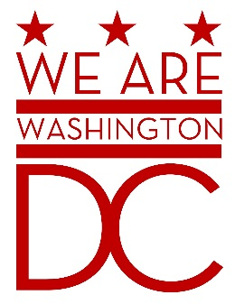

**MEETING MINUTES**

**Tuesday, September 1, 2015**

**441 4th Street NW Suite 540 South**

**Washington DC 20001**

**6:30 – 8:00 p.m.**

The Meeting was called to order by Chairman Wingo. Members saluted the flag and recited the pledged allegiance. The roll was called with the following board members present**:**

Harry Wingo, Chairman

Victoria Pridemore, Vice Chair

Demetrius Mack, Member

Eric Perez – Member (via phone)

Herman Preston, Ex-Officio Member

Jamaal Lampkin, Member

Kim Davis, Member

Luke Dier, Member

Saif Khan, Member

Sidney Locks, Member

Steven Dazell, Member

Jacque Patterson, Member

Prince Brooks, Member

MOVA Staff in attendance were – Director Lambert and Brenda Hall

Members of the Public included the following:

Michael Lee VOAA

Mike Toblin DC-OPC

Michael Strong - CHEP

Melanie Avery - VOTR

Darren Phelps - SVA

Alex Bako – DCORM

James Syndor – DCMFC

Nachee Miller DAV

Aaron Smith AMVETS

Eric Hughes NLSP

Johnnie Collins AMVETS

Jay Spearman AARP

Chas Sampson – DOD

Chris Duffey – Red Cross

John Johnson – DCVFW

Michael Sindram – veteran

Marilyn Wyche – WVRC-DC

Anthony Davis – American Veterans Helping Veterans for Life

Detailed minutes are available based on the agenda .

Meeting was adjourned by Chairman Wingo at 8:00pm