**ADVISORY BOARD ON VETERANS AFFAIRS**

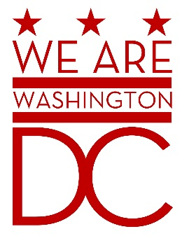

**MEETING AGENDA**

**Tuesday, October 6, 2015**

**441 4th Street NW**

**One Judiciary Square Suite 540 South**

**Washington DC 20001**

**6:30 – 8:00 p.m.**

1. **Call to Order (**Chairman**)**
2. **Pledge of Allegiance (**Chairman**)**
3. **Advisory Board Members Roll Call** (Sidney Locks)
4. **Special Guest (Closed Session)**

1. **Old Business** (Chairman)
2. Bylaws
   * 1. Review of requested changes
     2. Election of Positions
        1. Parliamentarian
        2. Secretary
        3. Sergeant At Arms
3. Strategic Plan
4. Formulation of Committees
   * 1. Election of chairs
        1. Housing/Homelessness
        2. Employment
        3. Education
        4. Entrepreneurship
        5. Recruitment
        6. Legislation
        7. LGBTQ
        8. Women Veterans
        9. Healthcare/Mental Health/PTSD
        10. Community Recognition/License Plate
        11. MOVA Board Speakers Bureau (Rock Star Committees)
5. Ethics Training Status
6. **New Business (**Chairman**)**
7. MOVA Updates
   1. **DD214 Upgrade Clinics**
   2. **Disability and Compensation Clinics**
   3. **Ebenefits.va.gov (In Person Proofing) Clinics**
8. Veterans Day Strategic Planning Committee
9. **Public Comment (Maximum 2 minute per person)**
10. **Upcoming (Events/Meetings/Holidays)**
11. **Adjournment (**Chairman**)**