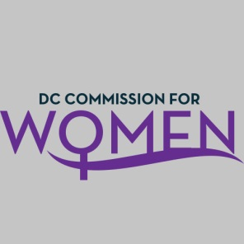
OFFICE ON WOMEN'S POLICY AND INITIATIVES
DISTRICT OF COLUMBIA COMMISSION FOR WOMEN

NOTICE OF PUBLIC MEETING
Thursday, May 21, 2015
6:45 PM – 8:00 PM
John A. Wilson Building
1350 Pennsylvania Ave. NW, Room G-9
Washington, DC 20004

The District of Columbia Commission for Women will host a monthly meeting on Thursday at 6:45 p.m. The meeting will be held at John A. Wilson Building, 1350 Pennsylvania Ave. NW, Room G-9, Washington, DC 20004.
For additional information, please contact Shana Armstrong, Associate Director at (202) 676-6199 or Shana.Armstrong@dc.gov

AGENDA
Welcome and Opening Comments……………………………..Dr. Carolyn Rudd
Introductions
- MOWPI Staff………………………………………………Director Kimberly Bassett
- Commissioners
BEGA Training
Overview & Mission of the Commission for Women………….Director Kimberly Bassett
Election of Officers……………………………………………….Chairwoman Rudd
- Vice Chair
- Secretary
- Treasurer
- Parliamentarian

Committee Selection/Assignment……………………………...Chairwoman Rudd
- Public Safety
- Policy & Legislative Initiatives
- Public Affairs/Fundraisers
- Health & Human Services
- Education, Labor & Training
Overview of Yearly Calendar-to-Date……………………….…Director Bassett
Comments, Questions, Concerns
Adjourn

