**ADVISORY BOARD ON VETERANS AFFAIRS**

**FOR**

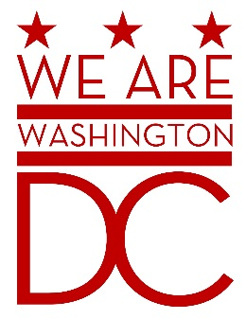

**MEETING AGENDA**

**Tuesday, May 5th 2015**

**441 4th Street NW**

**One Judiciary Square Suite870 North**

**Washington DC 20001**

**6:30 – 8:00 p.m.**

1. **Call to Order (**Chairman**)**
2. **Pledge of Allegiance (**Chairman**)**
3. **Advisory Board Members Roll Call** **(**Brenda Hall Recording Secretary**)**

Donald Brooks

Prince Brooks

Cecil Byrd, Ex Officio

Anthony Dale

Saif Kahn

Jacque Patterson

Ernest Postell, Sr.

Herman “Rip” T. Preston, Ex Officio

David Ramirez, Ex Officio

Nathan Sable

Claudia Treadwell, Ex Officio

Joe Wynn

1. **Discussion of Old Business (**Chairman**)**

Overview/Acceptance of April 7th Minutes

1. **Discussion of New Business (**Chairman**)**

Board requests assistance from MOTA (invite Anthony Stevens)

Upcoming OVA Budget Hearing

1. **Future Events**

Military Appreciation Month Activities

Loyalty Day and Military Appreciation Month Proclamation

DC War Memorial National Memorial Day Parade and Concert

1. **Adjournment (**Chairman**)**