ADVISORY BOARD ON VETERANS AFFAIRS
FOR
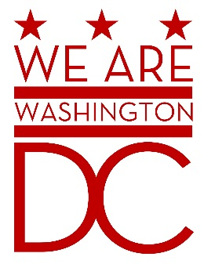

AGENDA
Tuesday, April 7th 2015

441 4th Street NW
One Judiciary Square Suite870 North
Washington DC 20001
6:30 – 8:00 p.m.

- Call to Order (Chairman)
- Pledge of Allegiance (Chairman)
- Advisory Board Members Roll Call (Recording Secretary)

Donald Brooks
Prince Brooks
Cecil Byrd, Ex Officio
Anthony Dale
Kathleen Hoppe
Saif Kahn
Jacque Patterson

Ernest Postell, Sr.

Herman “Rip” T. Preston, Ex Officio
David Ramirez, Ex Officio

Nathan Sable
Claudia Treadwell, Ex Officio
Joe Wynn

- Discussion of Old Business (Chairman)

Advisory Board on Veterans Affairs for the District of Columbia Annual Report – December 2014

- Discussion of New Business (Chairman)

- Open Government Overview (Traci Hughes – BEGA)

- Future Events

DC War Memorial
National Memorial Day Parade
- Adjournment (Chairman)

