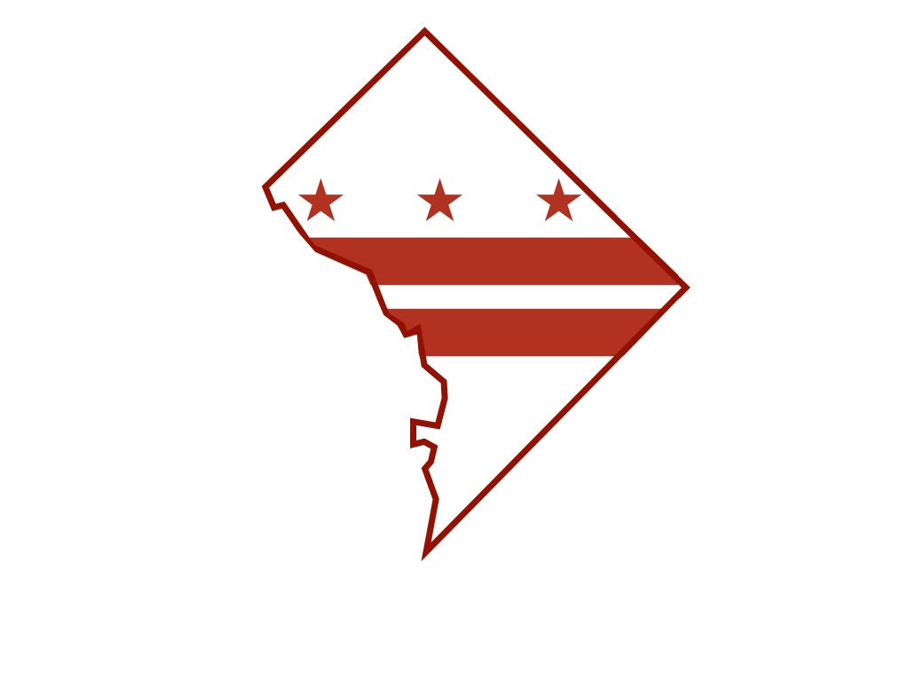
District of Columbia Department of Forensic Sciences

Department of Forensic Sciences

Science Advisory Board Meeting Minutes

Friday, January 15, 2016
Science Advisory Board Chairman Irv Litofsky brought to order, at 9:20 a.m., the meeting of the Department of Forensic Sciences (DFS) Science Advisory Board. In addition to the board chair, members present included Clifton Bishop, Joseph Bono, Michael Coble, William Grosshandler, Peter Marone and Sandy Zabell. A quorum was established to conduct board business. Minutes from the October 16, 2015, meeting were presented, read and approved.
Catherine Theisen’s resignation as DFS Deputy Director was announced by Dr. Jenifer A.L. Smith. She appointed Ms. Brittany Graham to serve as Interim Deputy Director, in addition to serving as Director of Training and Quality. Dr. Smith also announced the appointment of Ms. Karen Wiggins to Associate Director of the Forensic Science Laboratory and Mr. Troy Kelly’s appointment to Director of Crime Scene Sciences.
Function, role and responsibility of the advisory board were key areas reviewed in unofficial draft regulations developed by General Counsel Robert Hildum, who explained that upon completion, a more rigorous review for legal sufficiency would be conducted later by the Office of the Attorney General. It is anticipated that the board’s suggestions and recommendations will be incorporated into an updated version of the working draft document.
Dr. Luke Short reported substantial progress made toward establishment of the Forensic Chemistry Lab. Since the board’s last meeting, resources have been approved and loaded for the final installation of equipment and the development of forms, SOP’s and sample and validation plans have been completed. Dr. Morris Blaylock, of the Public Health Laboratory’s Microbiology Unit provided an overview of the Laboratory, focusing specifically on the lab’s organizational structure, stakeholder relationships, staffing challenges and the division’s responsibility for disease surveillance.

DFS staff, led by Dr. Horng Kan (Public Health Laboratory/Bio Terrorism), has been tracking and reporting twice monthly progress and action steps taken to correct deficiencies in response to 29 Q-CAR’s resulting from an inspection by the Centers for Disease Control and Prevention (CDC) Division of Select Agents and Toxins (DSAT). On behalf of Dr. Kan, Dr. Anicet Dahourou (Public Health Laboratory/Virology) presented an overview of the programmatic departures and corrective action.

A letter to DFS from the Public Defender Service (PDS), the DFS response letter to PDS and Cognitive Bias training of DFS staff were discussed briefly.
The board was introduced to Technical Leader Susan Welti and Manager Andrea Borchardt of the Forensic Biology Unit. The analysts reported on the unit’s latest techniques and testing protocols, quality assurance standards, SOP review, external audits and lab enhancements.
Following a LIMS review by Paul Reedy, a report by Dr. Smith on DFS supplemental spending and a query from Chairman Litofsky to DFS General Counsel regarding the expiration of board appointments and the reappointment process, the meeting adjourned at 2:15 p.m.
An audio recording of the meeting is available upon request.

