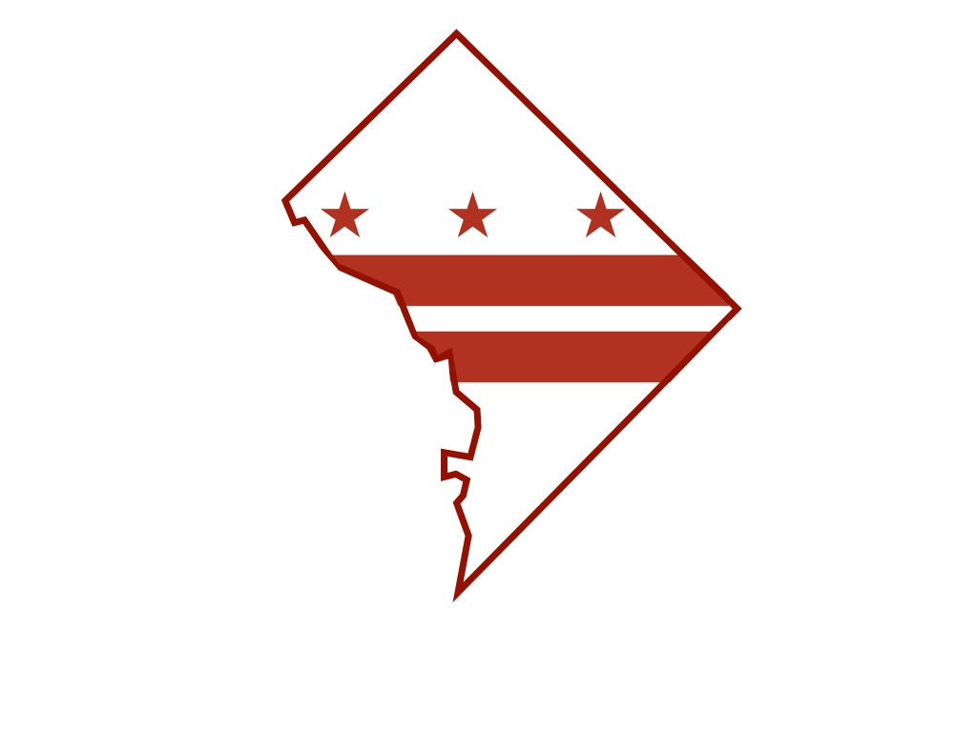
District of Columbia Department of Forensic Sciences

Department of Forensic Sciences

Science Advisory Board Meeting

Friday, January 9, 2015

Dr. Max M. Houck, Department of Forensic Sciences (DFS) Director, calls the Science Advisory Board WebEx meeting to order at 9:13 a.m., Friday, January 9, 2015. He announced recording of the web-based meeting and recognized onsite attendees during roll identifying: board member William Grosshandler, DFS Deputy Director Christopher Maguire, DFS General Counsel Christine Funk, Executive Assistant Herbert Thomas and public witness Julia Burl of the Public Defender Services for the District of Columbia. Meeting participants via telepresence included Yi-Ru Chen, DFS Chief of Operations, Science Advisory Board Chair Irv Litofsky and board members Charlotte Word, Jay Siegel, Joe Bono and Clif Bishop.
A quorum was established to conduct board business.
Board Chair Irv Litofsky presented the October 7, 2014, meeting minutes. Following the board’s review and approval, the minutes were adopted.
There were no reports of allegations received by DFS General Counsel Christine Funk during the quarter. The Science Advisory Board subgroup, comprised of Clif Bishop, Michael Coble, Charlotte Word and Sandy Zabell, was commended for their contributions to the ‘Interpretation of Complex DNA Mixtures’ report submitted to the Department of Forensic Sciences (DFS). Director Houck acknowledged receipt of the report and posting of the document to the DFS website. Also noted were two other related reports.
Presently, development of the department’s DNA protocol is ongoing and training of DNA analysts is anticipated by the end of January 2015. Director Houck pointed out that until the new SOP (Standard Operating Procedure) is in place, DNA interpretations will not be conducted. DFS General Counsel Funk reported that the DNA mixture case responsible for the recent attention raised regarding this issue has been resolved.
Deputy Director Christopher Maguire provided an update on paraDNA, the presumptive test for looking at stains. The plan is to implement the methodology to case work as a screening test by the end of January. The impact would mean
2
providing DNA results within days or hours rather than months. The outcome of a bid for National Institute of Justice (NIJ) funding for the project is anticipated in February 2015.
The Digital Evidence Unit is accepting evidence. Initially, cell phones will be the concentration for the current staff of four. Additional positions are expected to be filled. The Forensic Science Laboratory achieved aggressive targets in productivity for end-of-year goals. DFS leadership is currently working on 2015 goals. Crime scene scientists are deploying to crime scenes. The unit has acquired five crime scene vehicles and the acquisition of additional vehicles is planned.
The board was informed about the new administration, its leadership, the reporting structure and the elimination of the Deputy Mayor for Public Safety and Justice from this structure. This change will impact the legislatively mandated Stakeholders Council, chaired by the Deputy Mayor for Public Safety and Justice. During a recent briefing, Director Houck informed the Deputy City Administrator of the importance in resolving the matter before the Council convenes the next meeting. It is not certain whether legislative changes will be necessary.
Board member Grosshandler reported that teleworking for DFS employees was a point of interest raised during the October 7, 2014, staff dialogue. Director Houck stated that General Counsel Funk would research the labor relations issue and report her findings.
The board briefly discussed potential meeting dates and adjourned at 9:50 a.m.
An audio recording of the meeting is available upon request.

