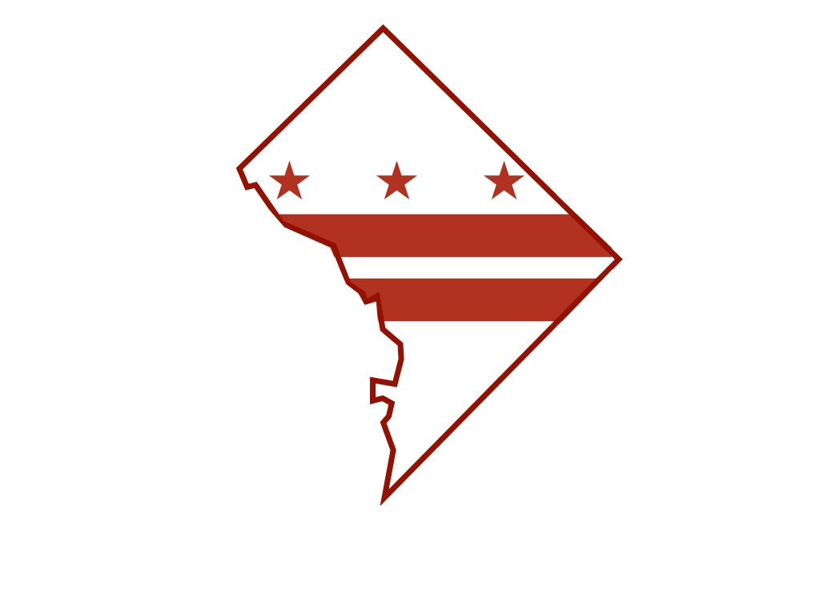
District of Columbia Department of Forensic Sciences

Department of Forensic Sciences

Science Advisory Board Meeting Minutes

Friday, October 2, 2015
The meeting of the Department of Forensic Sciences Science Advisory Board was brought to order at 9:20 a.m. by Board Chairman, Irvin Litofsky. In addition to board chair Litofsky, the current six board members in attendance included Clifton Bishop, Joseph Bono, Michael Coble, William Grosshandler, Peter Marone and Sandy Zabell. There was a quorum to conduct board business.
The June 16 meeting minutes were presented, read and approved, as corrected, to accurately identify receipt of the audit report from the ANSI-ASQ National Accreditation Board.
General Counsel Robert Hildum led a discussion concerning the Science Advisory Board regulations, notifications, board reviews and advising the Mayor and the Council of the District of Columbia on scientific matters. At the conclusion of Mr. Hildum’s talk, Deputy Director Catherine Theisen described the Quality Corrective Action Report (Q-CAR) process and timelines. The review was presented to assist in the board’s further discussion in determining the method and frequency of disclosures.
Deputy Mayor Kevin Donahue announced the October 28th City Council hearing for Dr. Jenifer Smith’s nomination for appointment as Director of the Department of Forensic Sciences. Deputy Mayor Donahue reported that the Mayor’s and the City Council’s commitment to DFS is supported by the substantial financial investment in the department.
Q-CAR scenarios, corrective action and staffing in the Latent Fingerprint Unit (LFU) were the focus of a presentation by LFU Manager, Jessica Beckman. Lead Scientist Laura MacBean discussed the Forensic Biology Unit’s (FBU) process and technique for 29 cycle and the allele frequency worksheet. She identified the intensive training, testing and independent review response in which FBU scientists have been engaged.
Dr. Jenifer Smith announced an October 30, 2015, STRmix implementation review panel convening at the Consolidated Forensic Laboratory for evaluative support of FBU.
The outcomes of assessments conducted during an ANAB surveillance visit were reviewed by Dr. Catherine Theisen. Accreditation for the Digital Evidence Unit is planned.
The Laboratory Information Management System (LIMS) went live October 1, 2015, at DFS. Simon Kert reported on the system’s capability for real-time evidence tracking and project/record management across different laboratory operations. Luke Short presented the DFS plan for the development of a lab to perform chemical analysis of synthetic cannabinoids.
Following a brief discussion concerning receipt of a letter from the Public Defender Service, ethics training and dc.gov email addresses anticipated for board members, the meeting adjourned at 2:52 p.m.
An audio recording of the meeting is available upon request.

