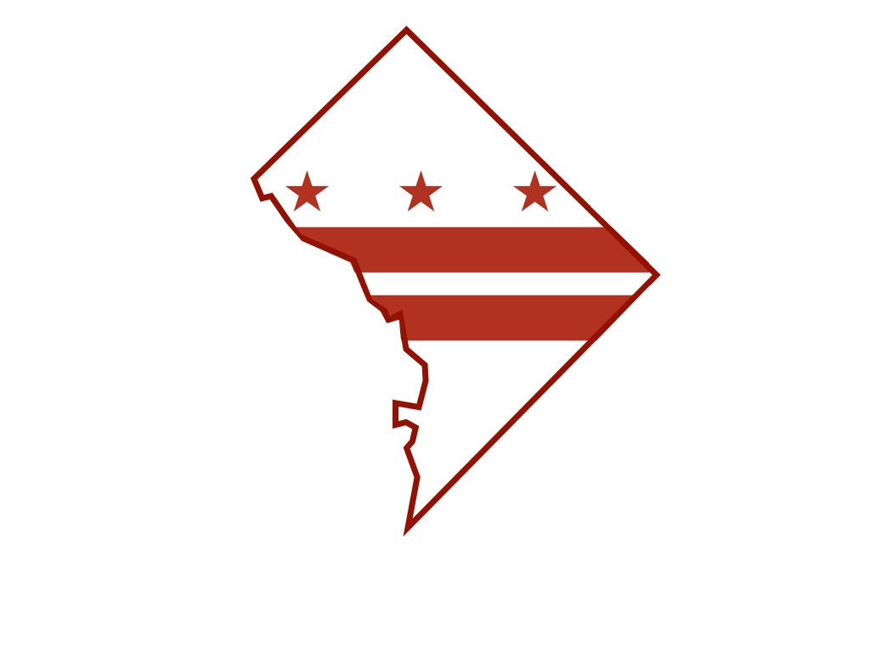
District of Columbia Department of Forensic Sciences

Department of Forensic Sciences

Science Advisory Board Meeting Minutes

Tuesday, June 16, 2015

DFS Interim Director, Dr. Roger A. Mitchell brought greetings to board meeting attendees and deferred to Science Advisory Board Chairman Irv Litofsky who calls the meeting to order at 9:20 a.m., Tuesday, June 16, 2015. Chairman Litofsky conducted roll call of current board members in attendance: Clif Bishop, Joe Bono, Mike Coble, Bill Grosshandler, Pete Marone, Sandy Zabell. A quorum was established to conduct board business.
The April 24 meeting minutes were presented, read and approved as corrected to accurately reflect the board’s receipt of the audit report from the U.S. Attorney’s Office, instead of the Office of the Attorney General, as well as the pending and subsequent receipt of the audit report from the ANSA-ASQ National Accreditation Board.
Deputy City Administrator/Deputy Mayor for Public Safety and Justice, Kevin Donahue, discussed his background and experience. He described the chronology of events and the decisions made related to DNA interpretation reports. Dr. Mitchell underscored the lack of complete transparency of past practices by the laboratory and the importance of the board’s oversight and role in quality control improvements, process and implementation. He further suggested the assembly of board subcommittees to address issues specifically related to individual laboratory divisions and units.
Robert Hildum, General Counsel, informed the board of pending recommendations for promulgating rules governing how the board would operate. A draft document is anticipated.
Forensic Science consultant, Dr. Jenifer A.L. Smith of the Pennsylvania State University Forensic Science program presented her findings concerning DNA mixture interpretation factors leading to consequences associated with DNA problems. Dr. Smith outlined a comprehensive response plan incorporating a retraining program for scientists, recruitment and the involvement of outside experts.
A discussion concerning quality control, ANAB non-conformities, corrective action and other quality-related issues was led by Deputy Director of Quality, Karen Wiggins. Details surrounding receipt of an allegation involving a 29 cycle complaint from the USAO, of which the board was notified, were addressed by Robert Hildum, Dr. Catherine Theisen and Dr. Smith. A response to the complaint was reported to be forthcoming.
Board member Bill Grosshandler moved that, “the entire board receives every complaint, consistent with the statute, by email in a timely fashion.” The motion was seconded and passed.
The meeting adjourned at 1:50 p.m.
An audio recording of the meeting is available upon request.

