**ADVISORY BOARD ON VETERANS AFFAIRS**

**FOR**

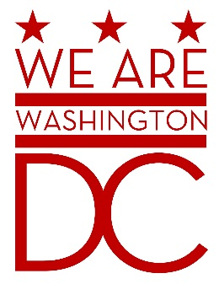

**MEETING MINUTES**

**Tuesday, June 2nd 2015**

**441 4th Street NW Suite 540 South**

**Washington DC 20001**

**6:30 – 8:00 p.m.**

The Meeting was called to order by Chairman Postell. Members saluted the flag and pledged allegiance. Recording Secretary Brenda Hall called the roll – with the following members/persons was present**:**

Donald Brooks

Prince Brooks

Cecil Byrd, Ex Officio

Joe Wynn

Saif Khan

Brenda Hall (OVA Staff)

Tammi Lambert (MOVA)

Delano Hunter (MOVA)

Anthony Stevens (MOTA)

Ernest Postell, Sr.

David Ramirez, Ex Officio

Claudia Treadwell, Ex Officio

CSM Preston, Ex-Officio

Syndey Locks

James Sydnor

WAWDC Chairman Postell called the meeting to order after roll call and pledge o0f allegiance the Chairman introduced the Mayor’s Office of Veterans Affairs Director,

WAWDCMOVA Director Lambert gave a brief overview of her vision for the office and introduced Mr. Stevens from Mayor’s Office of Talents and Appointment.

WAWDCMr. Stevens (MOTA) explained the process for submitting applications and reapplying for the Mayor’s Board on Veterans Affairs. There was much discussion, with the group understanding that all members MUST reapply for reconsideration through MOTA application online.

WAWDC Members discussed having a sit down with the Mayor to discuss their concerns relating to the Office of Veterans Affairs and lack of mentioning veterans in the SODA.

WAWDCAttendees requested that a link be provided to them via email for reapplying for consideration to the Board.

WAWDCMeeting Adjourned at 8:30pm