ADVISORY BOARD ON VETERANS AFFAIRS
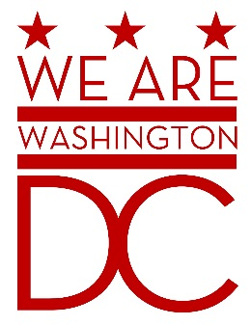

MEETING AGENDA
Tuesday, 2 February 2016

441 4th Street NW
One Judiciary Square Suite 540 South
Washington DC 20001
6:30 – 8:00 p.m.

- Call to Order
- Pledge of Allegiance
- Advisory Board Members Roll Call
- Agenda
- Approval of Minutes
  - See http://www.bega-dc.gov/board-commissions-meetings/mayors-advisory-board-veterans-affairs for audio file.
- Special Guests
  - General (ret) John N. Abrams, President and CEO, Abrams Learning Information Systems
  - James Albino, VA Assistant Secretary, Intergovernmental Affairs
  - Major General Errol Schwartz, Commanding General, D.C. National Guard
  - Darren Lloyd, Program Manager, Selective Service System
- Director’s Report
- Committee Reports

- Old Business (Chairman)
  - Discussion of Strategic Plan and Board Committee Assignments (Vice Chairman)
  - Discussion of By-Laws amendment regarding voice votes
    - At the December meeting, a proposal to amend line 111.7 to read “All votes shall be done by voice Vote. Following the voice vote, any member may call for a roll-call vote. If the call is seconded, a roll call vote will be conducted.”
    - Having introduced the proposal at its December meeting, the board can vote on it in February.
- New Business (Chairman)
  - TBD
- Public Comment (Maximum 2 minute per person)
- Upcoming (Events/Meetings/Holidays)
  - Next board meeting: 1 March 2016, 6:30-8pm. See http://www.bega-dc.gov/board-commission/meetings for agenda
- Adjournment

