**ADVISORY BOARD ON VETERANS AFFAIRS**

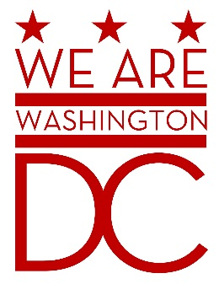

**MEETING AGENDA**

**Tuesday, 5 January 2016**

**441 4th Street NW**

**One Judiciary Square Suite 540 South**

**Washington DC 20001**

**6:30 – 8:00 p.m.**

1. **Call to Order**
2. **Pledge of Allegiance**
3. **Advisory Board Members Roll Call**
4. **Agenda**
5. **Approval of Minutes**
6. **Special Guests** 
   1. Gen (ret) John N. Abrams, President and CEO, Abrams Learning Information Systems
   2. James Albino , VA Assistant Secretary, Intergovernmental Affairs
   3. General Schwartz, Commanding General, D.C. National Guard
7. **Director’s Report**
8. **Committee Reports**
9. **Old Business** (Chairman)
   1. Discussion of Strategic Plan and Board Committee Assignments.
   2. Discussion of By-Laws amendment regarding voice votes
      * 1. At the December meeting, a proposal to amend line 111.7 to read “All votes shall be done by voice Vote. Following the voice vote, any member may call for a roll-call vote. If the call is seconded, a roll call vote will be conducted.”
        2. Having introduced the proposal at its last meeting, the board can vote on it in January.
10. **New Business (**Chairman**)**
    1. TBD
11. **Public Comment (Maximum 2 minute per person)**
12. **Upcoming (Events/Meetings/Holidays)**
13. **Adjournment**