**ADVISORY BOARD ON VETERANS AFFAIRS**

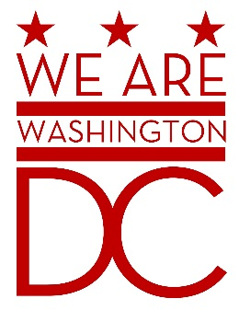

**MEETING AGENDA**

**Tuesday, 7 June 2016**

**441 4th Street NW/One Judiciary Square**

**11th floor. Room number TBD**

**Washington DC 20001**

**6:30 – 8:00 p.m.**

1. **Call to Order**
2. **Pledge of Allegiance**
3. **Advisory Board Members Roll Call**
4. **Agenda**
5. **Approval of Minutes**
   1. Minutes sent by email to board members.
6. **Special Guests** 
   1. Veterans’ Employment and Training Service, U.S. Department of Labor
      1. Bill Metheny, Director, Office of Field Operations, [metheny.william.p@dol.gov](mailto:metheny.william.p@dol.gov), (202) 693-4739
      2. 200 Constitution Ave NW S-1325, Washington, D.C. 20210-0001, http://www.dol.gov/vets/
   2. Psychosocial Rehabilitation Recovery Center (PRRC), DC Veterans Affairs Medical Center
      1. 50 Irving Street NW, Washington, DC 20422
      2. Ms. Yvonne Grissett, Certified Peer Support Specialist & WRAP Facilitator, (202) 745-8000 ext. 56445, [Yvonne.Grissett@va.gov](mailto:Yvonne.Grissett@va.gov)
      3. Mr. Maurice Harrison, Certified Peer Support Specialist & WRAP Facilitator, [Maurice.Harrison@va.gov](mailto:Maurice.Harrison@va.gov)
      4. Mr. Eric Birts, Certified Peer Support Specialist & WRAP Facilitator, [Eric.birts@va.gov](mailto:Eric.birts@va.gov)
7. **Director’s Report**
   1. TBD
8. **Committee Reports**
   1. Updates to objectives from strategic plan
9. **Old Business** (Chairman)
   1. Discussion of need to create a Recording Secretary position to create and post audio recordings of meetings.
10. **New Business (**Chairman**)**
11. **Public Comment (Maximum 2 minute per person)**
    1. American Veterans Committee
    2. Veterans Leadership Coalition
12. **Upcoming (Events/Meetings/Holidays)H**
    1. Hearing on free ID/Driver’s License: June 9th, 11:00 a.m., in room 500 or 412.
13. **Adjournment**