**ADVISORY BOARD ON VETERANS AFFAIRS**

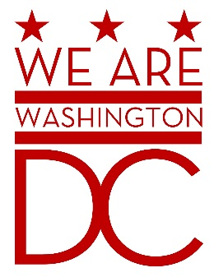

**MEETING AGENDA**

**Tuesday, May 3, 2016**

**441 4th Street NW**

**One Judiciary Square**

**Old Council Chambers**

**Washington DC 20001**

**6:30 – 8:00 p.m.**

1. **Call to Order**
2. **Pledge of Allegiance**
3. **Advisory Board Members Roll Call**
4. **Old Business**
   1. Bid Farewell to Prince Brooks & Donald Brooks
   2. Introduction of New Board Members
5. **New Business** 
   1. June 7, 2016 council meeting will be held on the 11th floor. Room number TBD. (Old Council Chambers will be in use by the board of elections.)
   2. Board Agenda/Meeting Format
   3. Recording Secretary
   4. Committees/Sub Committees - Discussion
6. **Public Comment**
7. **Upcoming Events**
   1. Memorial Day Observance – 25 May 2016
8. **Adjournment**