

Occupational and Professional Licensing

**District of Columbia Board of Funeral Directors 1100 4th Street, SW Suite 400**

**Washington, DC 20024**

**February 13, 2025 at 1:00 P.M. Minutes (Virtual Meeting)**

**\*\*This meeting is governed by the Open Meetings Act. Please address any questions or complaints arising under this meeting to the Office of Open Government at** [**opengovoffice@dc.gov**](mailto:opengovoffice@dc.gov)

The District of Columbia Board of Funeral Directors held its scheduled meeting on Thursday, February 13, 2025. This meeting was held virtually via Zoom.

The meeting was called to order at 1:00 pm by the Board Chair, Mr. John McGuire

# Attendance

Board Members Present: Board Chair, Mr. John McGuire, Consumer Member, Mr. Ernest

Boykin, and Board Member Mr. Randolph Horton

Staff: Mrs. Tiffany Crowe Director, Ms. Jacqueline Noisette, Deputy Director; Ms. Nicole McClendon, Program Manager, Ms. Allison Wade, Board Administrator, Kimberly Troxler Program Support Specialist, Ms.

Shakira Richardson CPU Program Manager, Demetrius Norman, Chief Customer Experience Officer, Mr. Jatarious Frazier, Policy Analyst, Jennifer Durden, Paralegal Specialist, Charles Basham III, Program Manager, Terry Bryant, Program Support Specialist, A’layza Mitchell

Legal Counsel: Ms. April Randall

Special Guest: Alex Pope

# Agenda Item: Comments from the Public

Alex Pope of Pope Funeral Home states that certain unlicensed people and businesses are advertising their services via the Internet. Board Chair Mr. McGuire asked for documentation for the said ads and advised Mr. Pope that a formal complaint should be put in through our CPU department. Ms. Nicole McClendon Program Manager and Shakira Richardson CPU manager confirmed the correct way to enter a complaint. Ms. Shakira Richardson also gave the link to DLCP’s CPU complaint form to Mr. Pope

# Agenda Item: Draft Minutes

Mr. Ernest Boykin pointed out two corrections that needed to be made,1. The spelling of Mr. Boykin’s first name. 2. The recommendations for Dunn and Sons Funeral Services need to state that a NOI and fine was sent to the establishment as well as the Funeral Director. Once the corrections were made, Mr. Ernest Boykin, properly seconded by Mr. Randolph Horton, and the Board voted unanimously to approve the January 9th, 2025, meeting minutes.

# Agenda Item: Review of Administrative Approved Applications

Upon motion duly made by Consumer Member Ernest Boykin and properly seconded by Board Member Randolph Horton the board voted unanimously to deny the following applications, due to documents presented not meeting the requirements.

1. Deles Watson
2. Tyesha Griffin

# Agenda Item: Legislative Update

Legal Counsel Ms. April Randall provided Clarity on the appeal process for all board members as well as the procedure for the applicants who have active appeals in our system.

# Agenda Item: Old Business

Upon motion duly made by Consumer Member Ernest Boykin and properly seconded by Board Member Randolph Horton, the board voted unanimously to defer the following applications due to the documents presented not meeting the requirements.

1. Deles Watson
2. Tyesha Griffin

**Agenda Item: New Business**

Allison Wade, Board Administrator, will provide all applicants who were in deferment with their approval/denial of their applications. Program Manager Ms. Nicole McClendon reminded board members to do their filing for BEGA.

# Agenda Item: Executive Session –

Upon a motion duly made by Board member Ernest Boykin and properly seconded by Mr. Randolph Horton–the board went into Executive Session, which is closed to the public, the Board voted to enter Executive Session at 1:17pm

Executive Session (Closed to the Public) to consult with an attorney pursuant to D.C. Official Code § 2- 575(b) (4) (A); D.C. Official Code § 2-575(b) (9) (13) (14) to seek the advice of counsel, D.C. Official Code Section 2-575(b)(9) to discuss disciplinary matters, and D.C. Official Code Section 2-775(b)(13) to deliberate upon a decision in an adjudication action or to discuss complaints/legal matters, applications.

# Agenda Item: Recommendations

Upon motion, duly made by Consumer Member Ernest Boykin, and properly seconded by Board Member Mr. Randolph Horton in the matter of W. H Bacon Funeral Home, Board Administrator Allison Wade will research possible revocation of license and present back to the board the findings.

The Board entered back into public session at 1:59pm

# Agenda Item: Adjournment:

Upon motion duly made by Mr. Randolph Horton, and properly seconded by Mr. Ernest Boykin, the Board unanimously voted to adjourn the meeting at 2:02 pm.

Respectfully submitted,

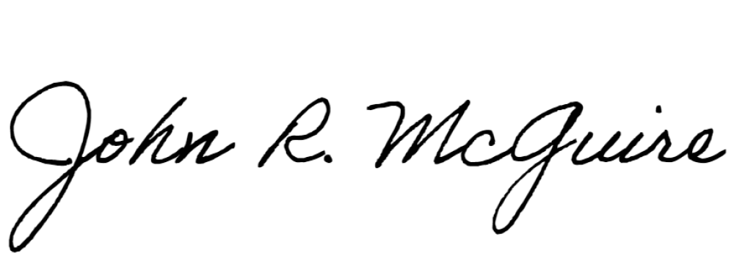Mr. John McGuire, Chairman

Date: 02/13/2025

Recorder/transcriber: Allison Wade, Board Administrator