REGULAR MEETING

Thursday, October 17, 2024
Video Conference Call
10:30 am-12:30 pm

Transcript of this Board meeting can be found here.

UNAPPROVED REVISED MEETING MINUTES

Board Members Present | Board Members Not Present | DOB Staff Present | Other Persons Present
Marc Fetterman, Vice Chair | Joel Causey | LaTrease Christian | Aaron
Matt Borger | Casey Studhalter | Helen Hooks-Scott | Max Brown, Group 360
Mike Brown |  | Sana Sandra Karbal | John Catlett, Catlett Code Consulting
Anthony Dale |  | Nicole Rogers | Lucia F.
Ed Kaufman |  |  | Guillermo Rueda, AIA
Gus Mehrdad |  |  | Rob Hawkins, Berlin Rosen
Harrison Miller |  |  | Maria
Keith Parsons |  |  | David Mallof, Ward 2 resident
Jeff Reiss |  |  | Max
Jason Wright |  |  | Mimi N.
Jeff Viano |  |  | Chris Pendley, AOBA
 |  |  | Alisonya Poole, DOEE
 |  |  | M. Preston
 |  |  | Tasneem Islam, DOEE
 |  |  | Jon Tung, P.E., Field & Tung
 |  |  | Erika Wadlington, DCBIA

1. Preliminary Matters

i. Call to Order and Roll Call
The meeting was called to order by Marc Fetterman, Vice Chairperson. Marc Fetterman has the role of Board Acting Chairperson because there is no Board Chairperson. Roll call of Board members and other persons present was initiated by Marc Fetterman. All members and other persons present participated via WebEx video conference.

ii. Adoption of Meeting Agenda
Marc Fetterman presented the meeting agenda for the Board’s approval. A motion to adopt the meeting agenda was made by Anthony Dale and seconded by Jason Wright. Without any objections, the agenda was adopted.

iii. Review and Adoption of Minutes of July 18, 2024, Regular Meeting
Marc Fetterman presented the meeting minutes from July 18, 2024, Board Meeting for the Board’s approval. The meeting minutes were approved unanimously upon motion made by Michael Brown and seconded by Jeff Viano. Without any objections, the minutes were adopted.

2. Code Change Proposals for Consideration

i. No new proposals
Amendment No. | Code/Section | CCCB Presentation | Procedural History | CCCB Action & Date

3. Administrative & Other Matters

i. Chief Edward “Ed” Kauffman will replace Chief Mitchell Kannry as CCCB member representing the Office of the Fire Marshall, DC Fire EMS

ii. Election of CCCB Vice-Chair
a. Anthony Dale nominated Marc Fetterman as CCCB Vice-Chair and Jason Wright seconded the nomination. Without any objections, Marc Fetterman was elected the Vice-Chair.

iii. CCCB Private-Sector Members Renewal of Appointments by MOTA.
a. The swearing in for the renewal of appointments may be held early next year.

iv. Adoption of 2023 Code Changes: Review of draft Codes by DC Agencies prior to its publication as 1st Notice of Proposed Rulemaking in the DC Register. Mike Brown led a discussion of items iv., v., and vi.
a. Michael Brown displayed and explained his “Code Development Calendar Projections,” attached to these minutes. The top row illustrates the remainder of the Construction Codes approval process. (This schedule incorrectly labels the “1st Notice of Proposed Rulemaking” as the “Second Public Comment Period.”)
b. A DOB-requested code change was approved by the CCCB in July and the draft Construction Codes were submitted to OAG in September.
c. Casey Studhalter is working with OAG on issues concerning the Green and Commercial Energy Codes.
d. After OAG review, the draft Construction Codes will be submitted to the Office of Policy and Legislative Affairs (OPLA) and then to the Executive Office of the Mayor.
e. This schedule envisions an initial public comment period in late December or January, followed by review of public comments by the CCCB and its TAGs in February and March.
f. This schedule envisions a 2nd Notice of Proposed Rulemaking will be published in the DC Register in April and the Codes will go into effect in June or July.

v. By November, the Department of Buildings (DOB) should have hired a staff member to assist with CCCB administrative matters.

vi. DC Council legislation requires DC to have a net zero code in effect by December 31, 2026.
Rows two and three of the “Code Development Calendar Projections,” attached to these minutes, illustrate the “2027 Building Construction Code.” Mike Brown proposes that the CCCB start work on additional amendments to the DC Construction Codes in late January 2025. DOB recommends that only ICC Codes be used. Board members desiring copies of ICC Codes should contact Mike Brown.

vii. Next CCCB Regular Meeting – November 21, 2024.

4. Comments by Board Members and Members of the Public

i. No additional comments were offered by Board members or by members of the public.

5. Adjournment

Meeting was adjourned at 10:58 am.

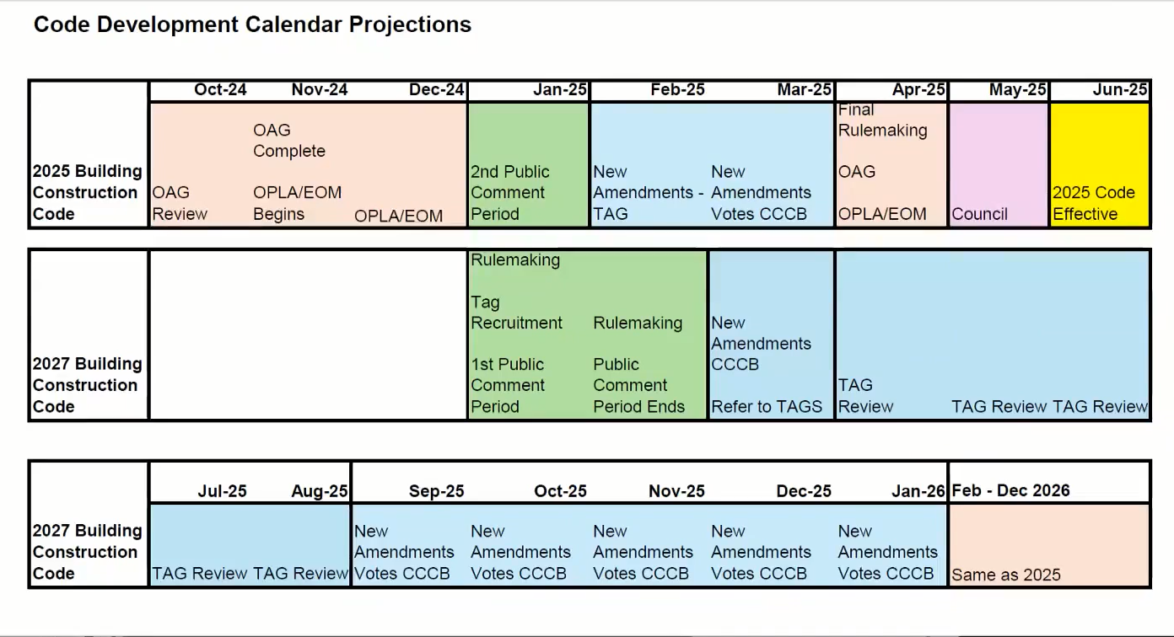

This meeting is governed by the Open Meetings Act. Please address any questions or complaints arising under this meeting to the Office of Open Government at opengovoffice@dc.gov.

