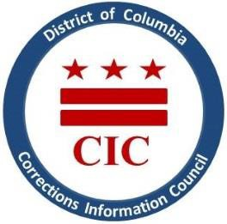
CIC | DC Corrections Information Council

CIC Quarterly Board Meeting
Date: Thursday, January 25, 2024
Location: 1400 I St. Suite, 400 Washington, DC 20005
Time: 6-7:30pm

Welcoming

- Roll Call
- Previous meeting minutes review
- Executive Director report
- BOP updates
- DOC updates
- Closed Portion to discuss personnel matters, pursuant to DC Code §2-575(B)(10)
- Re-Opening of meeting
- Closing Remarks

This meeting is governed by the Open Meetings Act. Please address any questions or complaints arising under this meeting to the Office of Open Government at opengovoffice@dc.gov.

