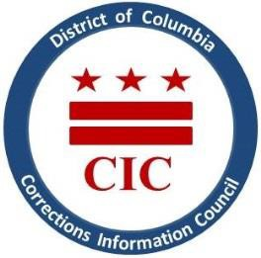
CIC | DC Corrections Information Council

CIC January Board Meeting
Tuesday October 18, 2022 11:00 AM
Join Teams Meeting:
https://teams.microsoft.com/l/meetup-join/19%3ameeting_NDE5NGM4YzctNjQ4ZS00NTQ0LTg3MTYtYzc0MmE2NWQwMzlj%40thread.v2/0?context=%7b%22Tid%22%3a%228fe449f1-8b94-4fb7-9906-6f939da82d73%22%2c%22Oid%22%3a%22ecb9c4c7-4d26-4e81-b51b-8f30991c7c6b%22%7d

Welcoming

- Roll Call
- April meeting minutes review
- Executive Director report
- USP Pollock updates
- MOU updates: BOP and DOC
- Closing Remarks
- Closed Portion: DOC transfers to St. Elizabeth’s

