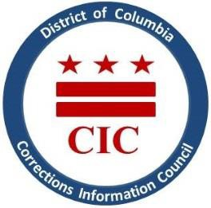CIC | DC Corrections Information Council

**CIC Quarterly Board Meeting  
Date: Tuesday, February 11, 2025  
Location: 1400 I St. NW, Suite 400 (Conference Room) Washington, DC 20005  
Time: 6-7:00pm**

Welcoming

1. Roll Call
2. Previous meeting minutes review
3. Executive Director report
4. BOP updates
5. DOC updates
6. Closing Remarks

***This meeting is governed by the Open Meetings Act. Please address any questions or complaints arising under this meeting to the Office of Open Government at*** ***opengovoffice@dc.gov*****.**