COAA JANUARY 2019 MINUTES
The following minutes are taken as the COAA/ MOAA and the public input was reported.
January 9, 2019 | 6: 00 PM | OFFICE ON AFRICAN AFFAIRS | 6th Floor
Meeting called by | Acting Chair Margaret Kamara called the meeting to order at 6:13 pm
Secretary | Acting Chair Margaret Kamara
Attendees | OAA: Director Mamadou Samba, Deputy Director Aly Kaba, Language Access Coordinator Gelila Getaneh, and Community Outreach Specialist Thierry Tchenko  Commissioners: Carmen Eliam, Hellen Fissihaie, Margaret Kamara, Etayenesh Asfaw, Salimata Sangare, Yodit Shibru, and Theodore Ngatchou  Commissioner Johanna Leblanc called in at 5:54 p.m. using the phone number and access code provided by Acting Chair Kamara but the telephone conference equipment was not available and she could not be joined to the meeting.  Aspiring Commissioner: Mariama Keita  Public: Sylvie Bello (Cameroon American Council), Léonce Byimana (Executive Director TASSC International), Stephanie Gilmore (UDCCC Program Coordinator); Yafet Girmay (National Black United Front - Vice chair of international affairs); Alain Ikombo (YADI); Andjelo Mwembya; Jackie Nagawa AWCAA; Ify Anne Nwabukwu AWCAA, Margrethe Horlyck-Romanovsky, Sheila Wojloh, and Bonyonoh Wojloh
AGENDA:

I. Opening – Call to Order
II. MOAA Updates and Announcements
  - Second Term Outlook Presentation - Gallaudet University, Kellogg Conference Center |
  - Monday, January 14, 2019 | 4:00 pm
- MLK Peace Walk and Parade - Anacostia Park Entrance, Good Hope Road SE | on
  - January 21 | 11:00 am
  - Presentation from MOAA Grantees:
  - Torture Abolition & Survivors Support Coalition International
  - African Women Cancer Awareness Association
  - Know Your Right Town Hall – Learn your rights as a taxpayer | April 23, 2019
  - Carla Benitez, Program Support Assistant | Department of Insurance, Securities and Banking
III. Commission Announcements
· Discussion of Bylaws (role of OAA and COAA)
· Expectations of COAA (meeting attendance, support of OAA, advocacy, participation)
· Executive Positions for 2019 (Chair, Vice Chair, and Secretary)
· Old business
Meeting minutes approval and published on website for 2018
Picture, date of appointment, Bio and pictures.
Business cards request form signed
IV. Public Comments
V. Adjournment.

OLD BUSINESS: The November 7, 2018 Minutes were approved without any amendments. All meeting minutes not previously approved have been approved for 2018.
Introduction | Acting Chair Kamara welcomed everyone to the first meeting of 2019 and called the meeting to order. Snacks were provided, compliments of the African Women Cancer Awareness Association
MOAA Updates & Announcements | Director Samba wished everyone a happy new year and introduced the OAA team, highlighting its newest members (Gelila Getaneh; Language Access Coordinator and Thierry Tchenko; Community Outreach Specialist). Director Samba also shared the news of him and Deputy Director Kaba being appointed by Mayor Muriel Bowser to serve second terms.  Two of the Metropolitan Police Department African Liaison Unit officers were introduced; Officers Kevin Johnson and Anam Mumtaz. They spoke about the ride along and outreach efforts of the unit and the OAA. Officer Johnson announced that the Unit was looking to hire an Amharic speaking officer and they were not required to be a DC resident. He shared the below in response to public inquiries on qualifications.  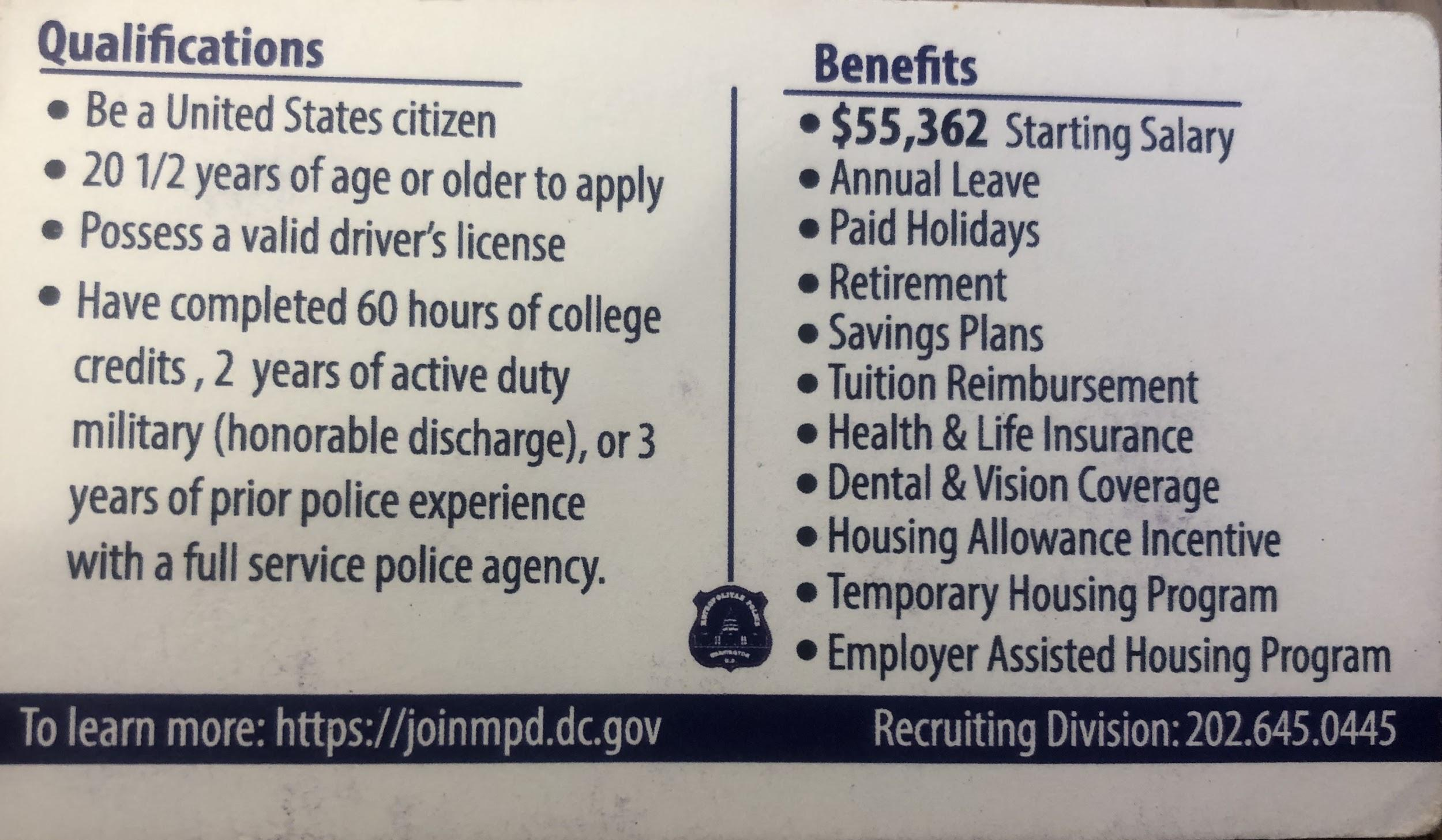  Director Samba encouraged the public to participate in the ride-along.  Director Samba then announced the appointment of seven new Commissioners and that the Office is looking to hire about four more Commissioners and encouraged the public to send any nominations to him. He also noted that he was in discussion with Mayor’s Office for selection of the Chair of the COAA.  He made announcements about upcoming event:  - Second Term Outlook Presentation at Gallaudet University Kellogg Conference on Monday, January 14, 2019; and  - MLK Peace Walk and Parade on January 21, 2019 at 11 am at Anacostia Park Entrance, Good Hope Road SE.  Director Samba left the meeting and Deputy Director Kaba lead the remainder of the meeting.  Presentations were made by two of the guarantees of the FY19 MOAA African Community Grant:  Torture Abolition and Survivors Support Coalition (TASS), Executive Director Léonce Byimana  95% of women supported are from Africa  More than 300 survivors  Ethiopia, Cameroon, Sudan and DRC  Services: Language, Legal and Career; Mentorship  Upcoming event: February 9, 2019 International Open House  Needs: housing for survivors  Website: tassc.org  African Women’s Cancer Awareness Association (AWCAA), President and Founder Ify Anne Nwabukwu  Services:  - Providing services to African and women  - Partnership with Zion Kitchen; on-site screening and looking to add new African restaurants to list of partners to provide on-site screening  Partnered with local hospitals that include Howard University, Holy Cross, George Washington to provide care and screening  - Insurance or immigration status is not required  - Hospitals will not charge a copay or any fees  - Secured new Grant from UMD-collapsible bed to help with screening and ultrasound  - Volunteers from 15 African countries  Needs: Volunteers needed one Saturday a month  Upcoming event: Will be at the NBC4 Expo January 12-13, 2019  Website: awcaa.org  Presentation made by Department of Insurance, Securities, and Banking, Program Support Assistant Carla Benitez  Services:  - Nonprofits, financial institutions for financial literacy  - Tax assistance resources  - Assisting immigrants with opening accounts  Upcoming event: Partnership with OAA Know Your Rights Town Hall: resource fair for public to learn about tax resources and to know their rights as taxpayers, March/April 2019. Details to come.
COAA Announcements | Members of the COAA introduced themselves to the public.  Interim Chair Kamara gave an overview of the role of the COAA, referencing DC ACT 16-313 of March 23, 2006, which established the Office on African Affairs and the Commission on African Affairs.  She went over some housekeeping items that included the expectations of the COAA; meeting attendance, quorum, participation, and advocacy.  She asked that Commissioners submit their pictures and bio for the OAA website. She encouraged the public to utilize the oaa.dc.gov website as a resource and to also become familiar with the other dc agencies.  Election of COAA officers to to take place at the next meeting in March for a Chair, Vice Chair, and Secretary. She encouraged Commissioners to consider the leadership roles and to review materials previously sent, which has information on the responsibilities of each role.  The COAA is looking forward to working with the OAA to serve the community in 2019 and will establish committees.
Public Comments | Deputy Director Kaba mentioned that part of the Mayor’s initiative is to work with professionals and families. The OAA is hosting an event on Thursday, January 17th at Boukom 6-8 pm with the Young African Professionals Network and Your Ethiopian Professionals and future event with the  Department of Parks and Recreation for families to drive the Mayor’s vision forward.  The floor was open for members of the public to introduced themselves and any projects they were involved with or any comments.  Yafet Girmay: (National Black United Front - Vice chair of international affairs): looking for partnership with COAA for Soweto Day in June;  Stephanie Gilmore: UDC Community College ESL program and informed the public of right as DC resident to a free associate degree at the University of DC Community College and other programs are available for professionals. She passed on flyers with information on programs offered at UDC.  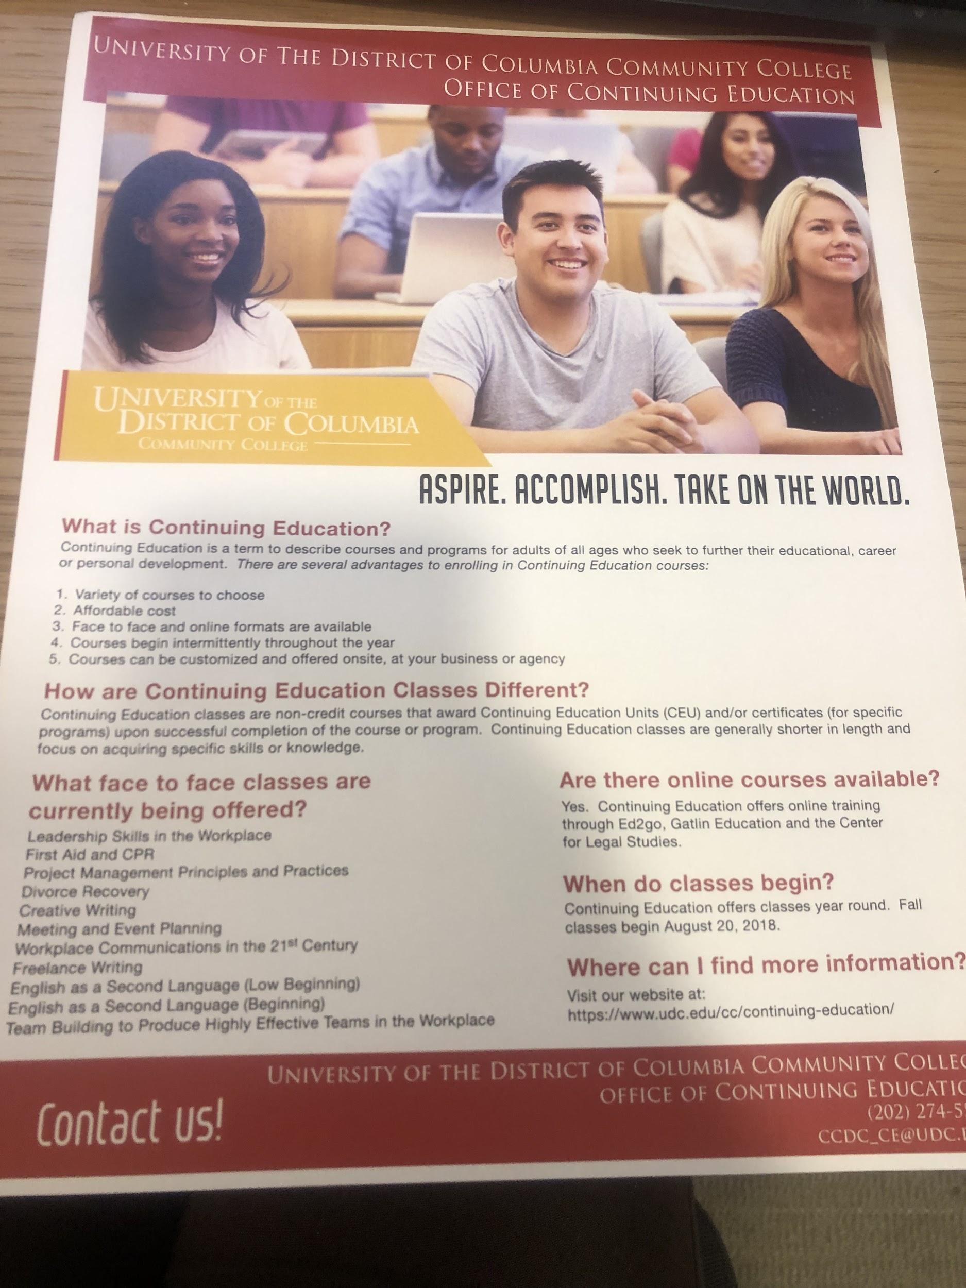  Sheila Wojloh: John Hopkins School of Medical, lived in Liberia, retired but still conducting research.  Bonyonoh Wojloh: first time attending meeting and found it to be informative.  Dr. Margrethe Horkyck-Romanovsky: postdoctoral fellow at NIH, informed public about NIH African Study #99-DK-002, targeting African born on the continent living in US.  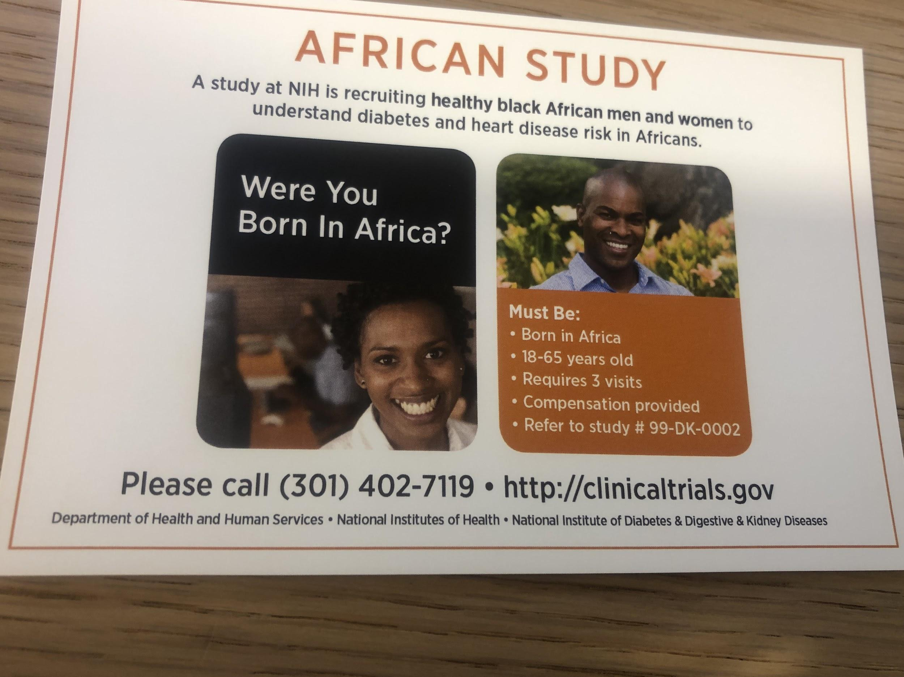  Jackie Nagawa AWCAA  Andjelo Mwembya and Alain Ikombo: gave an informal presentation on Young African Diaspora Initiative (YADI);  - Socio economic knowledge of Africans, wealth and legacy,  - Mission trips (2019 Ghana (June) and Senegal (October), 2 weeks each)  - yadileaders.org  - healthcare in the US and the continent  - Bi weekly meet-ups  Sylvie Bello (Cameroon American Council): spoke about the need for more advocacy from the OAA and COAA and credited the work of her team and many others for the resources available to OAA.
Adjourned: 7:58pm.

