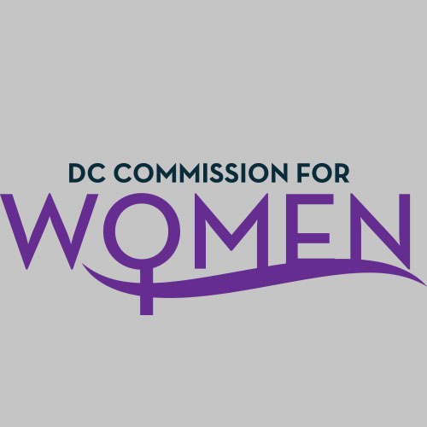
DC Commission for Women
Time: 6:45pm-8:00pm
Date: Tuesday, January 8, 2019
Location: 1350 Pennsylvania Avenue Room G-9

- Call meeting to order: The meeting was called to order at 6:47pm
- Roll Call: Roll call was completed at 6:51pm. A quorum was met.
- MOWPI Staff: Interim Director Angela Richardson; Alex Chambers
- Meeting Minutes: Meeting minutes for October 9, 2018 were circulated and approved with no edits.
- Correspondence & Announcements: None
- New Business
  - Chairwoman’s Report:
    - Chairwoman Porter gave acknowledgement to Mayor Bowser for being the first female mayor to reach her second term. As well as special acknowledgements to the former MOWPI Director Kimberly Bassett for transitioning to Secretary of DC.
    - Special thanks to all Commissioners for all of their work within the year of 2018, and encourages the Commissioners to bring forth new opportunities to serve while creating a presence in the MOWPI office.
    - Chairwoman Porter announces the election of the Executive Committee will be in place this evening.
    - Chairwoman Porter reads and reminds the Commissioners of the DC Commission for Women Standard ByLaw Articles, elected officers position duties, and follows by allowing Commissioners to ask questions in regards to the Executive Committee.

- Committee Reports:
  - Questions the role Commissioners will have in Policy; Commissioner Bess
  - MOWPI and Commissioners plans for civic engagement with STEM (prior worked with STEM); Commissioner Glover
  - Suggests mentoring and working with the young women of Excel Academy to reach empowerment and education. :Commissioner Tomkin
  - Would like to be informed if the Commission has a 2019 budget.: Commissioner Sarfati

- MOWPI Director’s Report:
  - Interim Director Angela Richardson re-introduces herself, her experience thus far, and speaks to the focus of this year. MOWPI will focus on 3 Pillars; Health and Wellness, Policy, and Empowerment.
  - March is Women’s History Month. The Women of Excellence Awards will take place on March 6, 2019. The location is TBD. Informs Commissioners of sharing their interest for women who they suggest should be awarded and to send it via email.
  - MLK Parade will take place January 21, 2019. Invites Commissioners to participate.
  - In efforts to engage and support more women of the District, Interim Director encourages Commissioners to attend/facilitate the Work Smart Salary Negotiation Workshops.
  - MOWPI would like to conduct a State of DC Women Report and asks Commissioners to send forth contacts that can assist.
  - Would like to invite Commissioners to NBC Health Fair at the Convention Center taking place this weekend, both Saturday and Sunday. Informs the Commissioners that there will be information covering all of the chronic diseases related to women.

- Announcements & Good of the Order
- Chairwoman Porter announces the DC Commission for Women Executive Committee Board of 2019!
Congrats & Welcoming
- Commission Chair: Jennifer Porter
- Vice Chair: Donella Brockington
- Treasurer: Veronica Nelson
- Secretary: Courtney Christian
- Parliamentarian: Jacquelyn Glover
- Invites Commissioners to attend Lobby Day and to support Statehood event which will take place February 13, 2019. : Commissioner Tomkin
- Invites Commissioners to attend the Posse Foundation 2019 Awards Ceremony located at the Lincoln Theatre on January 9, 2019 for a scholarship give away for High school seniors. : Commissioner Brockington
- Chairwoman thanks Commissioners for their reports, expresses her excitement for the new initiatives in place, and strongly encourages Commissioners to connect with chapter organizations, alumni orgs, etc.

- Next Meeting Date: The next meeting will be on February 12, 2019 at the Wilson Building.

- Motion to Adjourn: Meeting adjourned at 7:50pm.

