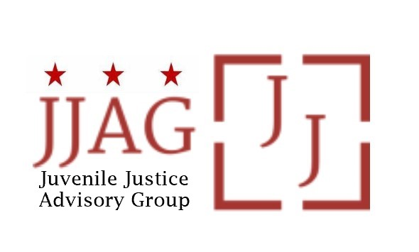

Juvenile Justice Advisory Group (JJAG)
Meeting Agenda
Tuesday, February 6, 2023
4:30pm - 6:00pm

Welcome | Welcome, Introductions and Check-In (Laura Furr, Chair) | 20 mins
Thanks and  Congratulations to Melissa! | Thank you to Melissa Milchman for her years of service to the JJAG and youth in DC! (Laura Furr, Chair)  - Video and live messages to Melissa from JJAG members and advisors  - Announcement of future opportunities to thank and congratulate Melissa  - Comments from Melissa | 15 mins
JJAG Business | JJAG Business Update (Melissa Milchman, JJ Specialist)  - MOTA update  - Title II applications  - CJJ Annual Conference + Youth Summit | 15 mins
Grantee Update | Update on Activities, Impact and Observations from Title II Grantee: CASA Bridges Program  - Presentation  - Questions and discussion of opportunities to address highlighted challenges observed among served youth and community | 30 mins
Updates and Announcements | JJAG Members and Advisors share updates or announcements and highlight upcoming opportunities for collaboration | 10 mins
Adjourn
This meeting is governed by the Open Meetings Act. Please address any questions or complaints arising under this meeting to the Office of Open Government at opengovoffice@dc.gov.

