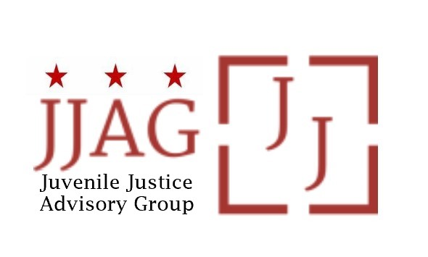

Juvenile Justice Advisory Group (JJAG)
Meeting Agenda
Tuesday, March 12, 2023
4:30pm - 6:00pm

Welcome | Welcome, Introductions and Check-In (Laura Furr, Chair) | 20 mins
In Memorium | Moment in Honor of Floyd Bronson | 10 mins
JJAG Business | JJAG Business Update (Susie Dhere, Laura Furr and Mylan Barnes)  - CJJ Annual Conference + Youth Summit - final call for interest  - JJAG Retreat Planning  - YLA update | 20 mins
Secure DC Final Update | Presentation and Discussion of Secure DC: Final Version and Implementation Heads Up (Lisa Wright, Senior Legislative Assistant, Councilmember Robert White) | 30 mins
Updates and Announcements | JJAG Members and Advisors share updates or announcements and highlight upcoming opportunities for collaboration | 10 mins
Adjourn

This meeting is governed by the Open Meetings Act. Please address any questions or complaints arising under this meeting to the Office of Open Government at opengovoffice@dc.gov.

