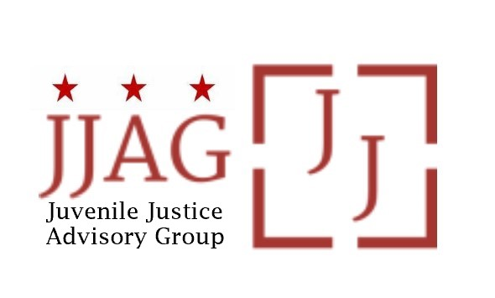

Juvenile Justice Advisory Group (JJAG)
Meeting Agenda
Tuesday, May 7, 2024
4:30pm - 6:00pm

Welcome | Welcome and Introductions (Laura Furr) | 15 mins
JJAG Business | JJAG Business Update (Laura Furr)  - Swearing in of returning and new members  - Retreat cancelation | 10 mins
Energizer | JJAG members share their “why” for committing time and energy to the JJAG (Mylan Barnes and Suzie Dhere) | 20 mins
JJAG Foundations | Long-serving JJAG members share accomplishments their proud of from their time on the JJAG (Dave Rosenthal, Brittany Mobley, Sheila Clark, Laura Furr) | 15 mins
Youth Leaders in Action Update | Update and discussion from YLA (Nataly Del Valle and Mylan Barnes) | 10 mins
Policy and Legislation Committee Update | Update and discussion from the Policy and Legislation Committee (Sheila Clark and Kyla Woods, Committee Co-Chairs) | 10 mins
Updates and Announcements | JJAG Members and Advisors share updates or announcements and highlight upcoming opportunities for collaboration | 10 mins
Adjourn

This meeting is governed by the Open Meetings Act. Please address any questions or complaints arising under this meeting to the Office of Open Government at opengovoffice@dc.gov.

