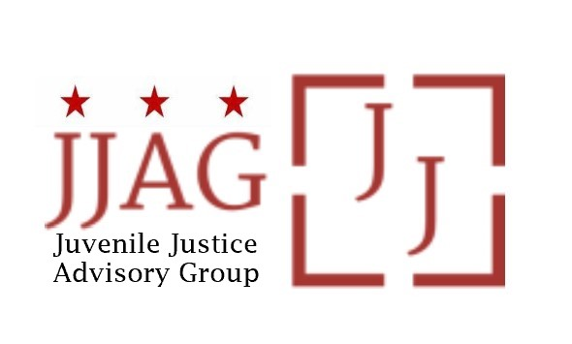

Juvenile Justice Advisory Group (JJAG)
Meeting Agenda
Tuesday, June 4, 2024
4:30pm - 6:00pm

Welcome | Welcome and Introductions (Laura Furr) | 15 mins
JJAG Business | JJAG Business (Laura Furr, OVSJG and CJCC) | 10 mins
CCE Presentation and Discussion | Council for Court Excellence present new Crossover Youth report followed by JJAG discussion (Tracy Velázquez, CCE) | 45 mins
CJJ Conference Recap | JJAG members who attended the 2024 CJJ Conference can share key takeaways and discuss next steps with full JJAG | 10 mins
Updates and Announcements | JJAG Members and Advisors share updates or announcements and highlight upcoming opportunities for collaboration | 10 mins
Adjourn

This meeting is governed by the Open Meetings Act. Please address any questions or complaints arising under this meeting to the Office of Open Government at opengovoffice@dc.gov.

