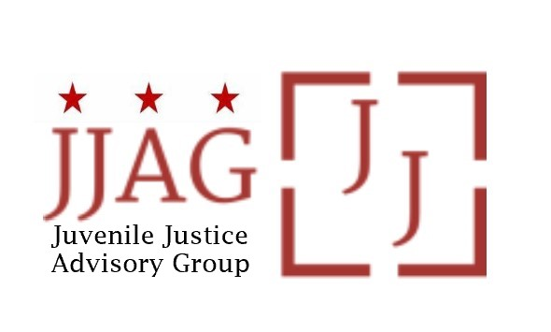

**Juvenile Justice Advisory Group (JJAG)**

**Meeting Agenda**

Tuesday, July 11, 2023

4:30pm - 6:00pm

|  |  |  |
| --- | --- | --- |
| Welcome | Welcome, Introductions and Check-In (*Mylan Barnes, Co-chair)* | 10 mins |
| JJAG Business | JJAG Business Update (*Melissa Milchman, JJ Specialist*)   * Brief status updates on grant reviews, 3-year plan and Title II   announcement   * 50th Anniversary of the Juvenile Justice and Delinquency Prevention Act (JJDPA) * Upcoming discussion on raising the minimum age of prosecution. * September meeting date | 15 mins |
| Delaware Site Visit to JPC | Recap of DE’s site visit to JPC as a model (*Toni Lemons, Compliance Monitory and R/ED Coordinator)*   * The Juvenile Processing Center (JPC) as a model supporting compliance with separation of youth and adults in custody, one of the four core requirements of the JJDPA | 10 mins |
| JJAG Issue Brief discussion | Discussion of proposed Issue Brief on detention and proven alternatives (*Brittany Mobley and Penelope Spain)*   * Review of draft recommendations * Discussion | 60 mins |
| Updates and  Announcements | Invitation to members, advisors, and partners to share updates, opportunities for collaboration, news, etc. | 5 mins |
| Adjourn |  |  |

*This meeting is governed by the Open Meetings Act. Please address any questions or complaints arising under this meeting to the Office of Open Government at*[*opengovoffice@dc.gov*](mailto:opengovoffice@dc.gov).