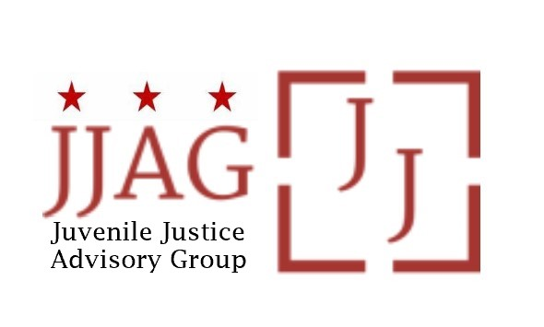

**Juvenile Justice Advisory Group (JJAG)**

**Meeting Agenda**

Tuesday, September 5, 2023

4:30pm - 6:00pm

|  |  |  |
| --- | --- | --- |
| Welcome | Welcome, Introductions and Check-In *(Mylan Barnes, Co-Chair)* | 10 mins |
| JJAG Business | JJAG Business Update (Melissa Milchman, JJ Specialist, Laura Furr, Chair and Mylan Barnes, Co-Chair)  Brief status updates on Title II submission, public access to JJAG’s R/ED report and recommendations + Equity  resolution  JJAG’s FY23 calendar and (re-)commitment +  reappointments  Heads up for October grant and 3-year plan activity  CJJ Youth Summit debrief | 10 mins |
| Impact of Curfew Change on Compliance | Discussion of New Curfew Enforcement and the Risk of Impact on Compliance (Laura Furr, Chair in discussion with JJAG reps from MPD, OAG and DYRS)  How will agencies ensure continued compliance with  deinstitutionalization of status offenders, one of the four core requirements of the JJDPA, while enforcing the  curfew? | 10 mins |
| Minimum Age of  Prosecution | Presentation and Discussion of a Minimum Age for  Prosecution (Melissa Goemann, National Juvenile Justice  Network) | 50 mins |
| JJAG Issue Brief Vote | Vote on JJAG Issue Brief on Alternatives to Detention (Laura Furr, Chair and Melissa Milchman, JJ Specialist) | 5 mins |
| Updates and  Announcements | Invitation to members, advisors, and partners to share  updates, opportunities for collaboration, news, etc. | 5 mins |
| Adjourn |  |  |

*This meeting is governed by the Open Meetings Act. Please address any questions or complaints arising under this meeting to the Office of Open Government at*[*opengovoffice@dc.gov*](mailto:opengovoffice@dc.gov).