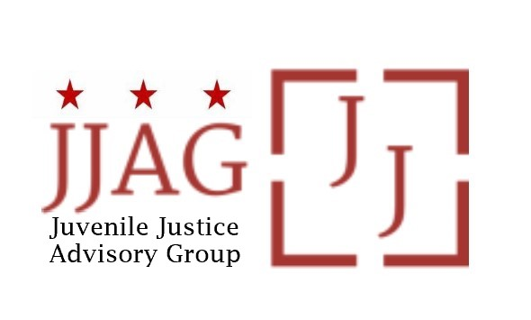

**Juvenile Justice Advisory Group (JJAG)**

**Meeting Agenda**

Tuesday, October 3, 2023

4:30pm - 6:00pm

In person: Room 1117, 441 4th Street NW

Virtual option available

|  |  |  |
| --- | --- | --- |
| Pre-Meeting Networking | Opportunity for those joining in-person to connect in Room 1117 | 4:00-4:30pm |
| Welcome | Welcome, Introductions and Check-In *(Laura Furr, Chair)* | 10 mins |
| JJAG Business | JJAG Business Update (*Melissa Milchman, JJ Specialist and Shanel Wilson, Mayor’s Office of Talent and Appointments*)   * Swearing in of JJAG new and returning members * Grant Award Announcements * State Plan Review | 15 mins |
| 211 Introduction | *Presentation and Discussion of new 211 Hotline (Sharafdeen Ibraheem, DC Child and Family Services Agency)* | 15 mins |
| Compliance Monitor Update | Update on Compliance Monitoring of Curfew Pilot (*Toni Lemons, Compliance Monitor and R/ED Coordinator)* | 15 mins |
| CLOSED SESSION, JJAG Voting Members Only | CLOSED SESSION: CJCC Data Presentation and Discussion (*Kristy Love, CJCC Executive Director*) | 35 mins |
| Adjourn |  |  |

*This meeting is governed by the Open Meetings Act. Please address any questions or complaints arising under this meeting to the Office of Open Government at*[*opengovoffice@dc.gov*](mailto:opengovoffice@dc.gov).