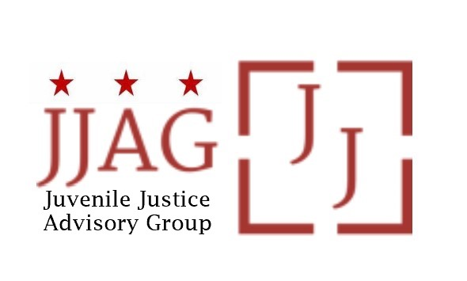

Juvenile Justice Advisory Group (JJAG)
Meeting Agenda
Tuesday, December 5, 2023
4:30pm - 6:00pm
WebEx link: https://dcnet.webex.com/dcnet/j.php?MTID=m403fbd92d8933b8c4da3a701bbcc0b30

Welcome | Welcome, Introductions and Check-In (Laura Furr, Chair) | 10 mins
JJAG Business | JJAG Business Update (Melissa Milchman, JJ Specialist)  - MOTA reappointments and Chair appointment discussion  - VOTE: CJJ membership renewal and YouthMove chapter dues  - Reminder: January meeting is in-person | 25 mins
JJDPA  Reauthorization Update | Update on Reauthorization Advocacy and Status of Juvenile Justice and Delinquency Prevention Act (Lisette Burton, JJAG Secretary and Act4JJ Co-Chair) | 15 mins
Grantee Update | Update on Activities, Impact and Observations from Title II Grantee: Access Youth  - Presentation  - Questions and discussion of opportunities to address highlighted challenges observed among served youth and community | 30 mins
Updates and Announcements | JJAG Members and Advisors share updates or announcements and highlight upcoming opportunities for collaboration | 10 mins
Adjourn
This meeting is governed by the Open Meetings Act. Please address any questions or complaints arising under this meeting to the Office of Open Government at opengovoffice@dc.gov.

