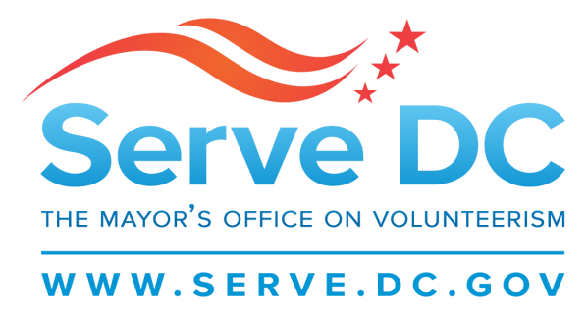

Commission for National and Community Service
Meeting
1.8.17
6:00PM
- Welcome
- Roll Call
- Reading of Past Meeting Minutes
- Grant Updates | Pamela Weinberg
- Site Visit Schedules | Pamela Weinberg
- Recent and Upcoming Events| Khadija Ismail
- Commission Election Timeline | Delano Hunter
- Commission Updates
- Commissioner’s Roundtable

Happy New Year Commissioners!
This memo serves to inform you about all of the wonderful events and programs Serve DC has embarked upon since our last meeting. We hope to provide you with a quarterly report each meeting and a report on past accomplishments and any upcoming events.
Grants Update
We are in our Competitive State Grant Award Process.
- Clarification letters were sent and responses are due by January 12th, 2018 by 5:00pm
- The Competitive Grant Application is due to CNCS on January 17th , 2018 by 5:00pm

Site Visit Schedule
All monitoring visits are scheduled between 9:00am and 1:00pm.
- 1/9/2018- Latin American Youth Center (LAYC)| 1419 Columbia Road NW, 20009|
- 1/11/2018- Washington Aids Partnership | 1400 16th ST NW, Suite 740, 20036|
- 1/16/2018- The Fishing School | 4737 Meade ST NE, 20019|
- 1/19/2018- After School All Stars | 1331 H ST NW, Suite 1100, 20005|
- 1/23/2018- Kid Power| 400 E ST SW, 20024|
- 1/25/2018- Earth Conservation Corps|2000 Half ST SW, 20024|
- 1/31/2018- Teens Run DC | 2607 Bowen RD SE, 20020|
- 2/2/2018- Relay Graduate School of Education
- 2/6/2018- Capital Area Asset Builders (CAAB) |1100 H ST NW, Suite 200, 20005|
- 2/8/2018- National Reentry Network | 3227 Dubois Place SE, 20019|
- 2/14/2018- City Year |1875 Connecticut Ave NW, Suite 414, 20009|
- 2/20/2018- AARP Experience Corps Foundation|601 E ST NW, 20049|
- 2/22/2018- Jumpstart|1101 14th ST NW, Suite 1001, 20005|
- 2/28/2018- Higher Achievement|317 8th ST NE, 20002|
- 3/6/2018- Literacy Lab|1003 K ST NW, Suite 500, 20001|
- 3/8/2018- Playworks|600 Pennsylvania AVE SE, 20003|
- 3/14/2018- Reading Partners|500 Penn ST NE, 20002|
- 3/20/2018- Teach for America |1805 7th ST NW, 20001|
- 3/22/2018- Center for Inspired Teaching| 1436 U ST NW, Suite 400, 20009|

Programmatic Site Visits: Locations and times are still being determined.
- 3/6/2018- Reading Partners| Wheatley Education Campus| 1:45pm-2:45PM
Upcoming Events/Recent Accomplishments

1/9/2018|Serve DC Adopted Joyful Food Market| King Elementary School|3200 6th ST SE, 20032|
1/13/2018|Thursday Network and Serve DC’s MLK Day Blanket & Toiletries Drive | Frank D. Reeves Center|10AM-3PM
1/15/2018| MLK Day of National Service| Pope Branch Park, Fairlawn Avenue & M Place SE, 20019| 9AM-12PM|

Recent Accomplishments

DC Resident Snow Team- Serve DC has improved the volunteer deployment system for 2017-2018 winter season. Please visit SNOWTEAM.DC.GOV for the DC Volunteer Snow Team registration Link. Sign up today, and “Adopt-A-Senior” who requires removal services for the duration of the winter under the Opportunities section of the site.

World Aids Day 2017- Serve DC partnered with the Mayor’s Office of LGBTQ Affairs for World Aids Day. Over 30 exhibitors set up their booths for the information fair and provided sexual health related information to attendees. Mayor Bowser and Raheem Devaugn provided remarks and an assembling of 2500 Health Kits followed. A workshop on “What is needed during an emergency for a person living with HIV and how to treat or care for a person with HIV during an emergency” was provided by DR. Goulda Downer of Howard University College of Medicine.
Toys for Tots- Serve DC partnered with The United States Marine Corps and Toys for Tots to distribute over 6000 toys to children aged 1-13 for the Christmas holiday.
Commission Election Timeline

Commission Updates

Commissioners’ Roundtable

