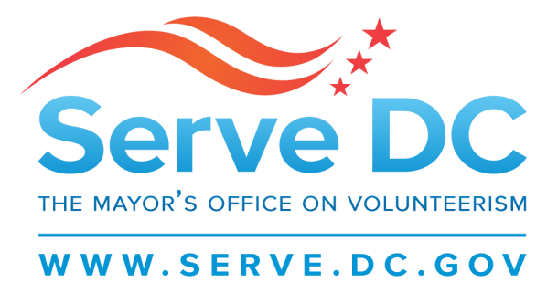

Commission for National and Community Service
Meeting
7.10.17
6:30PM

- Welcome
- Roll Call
- Reading of Past Meeting Minutes
- State Service Plan
- Formula Grant Updates
- Events
  - Recent Events
  - Upcoming Events
- Committee Updates
- New Business/Announcements
  - Donations Management Process

