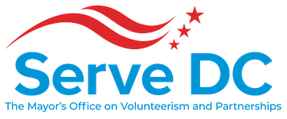

DC Commission on National and Community Service

2000 14th Street NW | Suite 101 | Washington, DC 20009 | 5.22.2019 | 6:30 PM

**Please join my meeting from your computer, tablet or smartphone.**   
[**https://global.gotomeeting.com/join/822852269**](https://global.gotomeeting.com/join/822852269)  
  
**You can also dial in using your phone.**   
**United States:** [+1 (646) 749-3122](tel:+16467493122,,822852269)   
  
**Access Code: 822-852-269**   
  
**New to GoToMeeting? Get the app now and be ready when your first meeting starts:**   
[**https://global.gotomeeting.com/install/822852269**](https://global.gotomeeting.com/install/822852269)

**AGENDA**

* Call to Order - **Chair Brandon Andrews**
* Roll Call - **Lavita Anthony, Executive Assistant**
* Approval of the Minutes
* Chair’s Opening Remarks **- Chair Brandon Andrews**
* Director’s Report – **Ayris T. Scales, Chief Service Officer**
* Operations Updates - **Larry Hicks, Deputy Director, Finance and Operations**
* Program Updates
  + AmeriCorps **- Jenny Kessler, National Service Officer**
  + Partnerships & Engagement
    - Emergency Preparedness - **Adriana Bonilla, Emergency Preparedness Specialist**
    - Donations Management - **Alexis Squire, Deputy Director, Partnerships and Engagement**
    - Volunteer Engagement - **Alexis Squire, Deputy Director, Partnerships and Engagement**
* Opportunities to Get Involved - **Victor Jimenez, Communications Manager**
* Set Next Meeting Date - **Chair Brandon Andrews**
* Adjourn