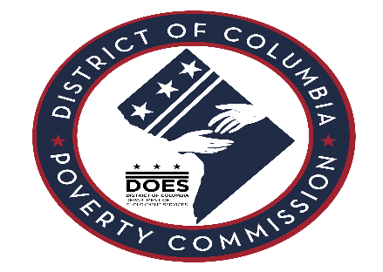
Meeting Agenda December 19, 2023

- Swearing-In Ceremony of Second Group
- Recap of Swearing-In Ceremony/First Meeting on Nov. 28th
- Governing Rules & Structure for Commission Meetings – Roberts Rule of Orders
- Recap of Ward 7 Listening Session
- Schedule One on Ones with Executive Director
- Discussion/Feedback about Draft Poverty Reduction Plan
- Update on Legislative Questions from DOES General Counsel and Next Steps
- Additional questions from commissioners
- Discussion around statement of work framework for new consultant contract
- Upcoming Events/Listening Sessions
- Poverty Commission Materials
- Focus for our January Meeting
- Idea generation/working session: Begin generating ideas for engagement strategy for core groups experiencing poverty: Youth, Elderly, Families, Individuals with disabilities, and other groups
- Adjournment

