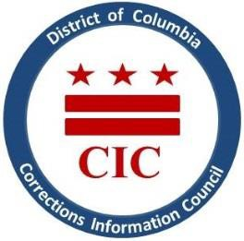
CIC | DC Corrections Information Council

CIC Quarterly Board Meeting

Location: Marion S. Barry, Jr. Building - 441 4th St NW, Room 1107 Washington, DC 20001
Date: Tuesday, November 14, 2023
Time: 6- 7:30pm

Welcoming
- Roll Call
- July meeting minutes review
- Executive Director report
- BOP updates
- DOC updates
- Current & Upcoming projects
- Q&A
- Closed Portion with Executive Director and CIC Board to discuss personnel matters,
pursuant to DC Code §2-575(B)(10)
- Reopening of meeting and closing remarks

This meeting is governed by the Open Meetings Act. Please address any questions or complaints arising under this meeting to the Office of Open Government at opengovoffice@dc.gov

